

Performance of the

Sacramento County Mental Health System

for CY 2022

Prepared by the

Sacramento County Mental Health Board

August 2023

Table of Contents

Executive Summary……………………………………………………………………………………………………………….3

Introduction…………………………………………………………………………………………………………………………..6

**Background……………………………………………………………………………………………………………………………7**

Demographics……………………………………………………………………………………………………………………7

Revenue 14

Mental Health Services 16

Needs of the County’s Mental Health System 17

Outpatient Services 18

Timeliness of Mental Health Services 18

Crisis Services 20

Dignity Health Mercy San Juan Outpatient Behavioral Health Crisis Services Collaborative (CSU) 20

Mental Health Urgent Care Center (MHUCC) 21

Community Wellness Response Team (CWRT) 22

Capacity of Services 23

Penetration Rates 24

**Retention Rates…………………………………………………………………………………………………………27**

Human Resources 29

# Executive Summary

The purpose of this report is to comply with the Sacramento County Mental Health Board’s (MHB) statutory mandate pursuant to Welfare and Institutions Code Section 5604.2(a)(5) to submit an annual report to the governing body on the needs and performance of the county’s mental health system.

Introductory material summarizes demographic information relating to the client beneficiaries, revenue sources, and the mission, vision, and principles of Mental Health Services.

Timeliness of services is presented in excerpts from the survey and report completed by the External Quality Review Organization (EQRO) for its FY 2020-21 Report[1], which included the following recommendations:

1) Review with DHCS the method currently used to measure the time to first offered and first kept appointment, which has resulted in meeting the standard 100 percent of the time. Also review whether the time to the second clinical appointment is at or near 100 percent.

2) Continue efforts to recruit and retain adequate psychiatry coverage and measure progress in terms of full-time equivalents (FTEs) and time to first psychiatry appointment.

3) Begin to track and report no-shows separately for psychiatrists and clinicians. Disaggregate data for adults, older adults, children, and youth in foster care (FC).

4) Determine a methodology to track time to response for urgent conditions and

implement. Track and report this data, disaggregating adults, older adults, children,

and FC.

Crisis services provided by more recently developed programs, such as Dignity Health Mercy San Juan Outpatient Behavioral Health Crisis Services Collaborative (CSU), the Mental Health Urgent Care Center (MHUCC), and the Community Wellness Response Team (CWRT), are described.

**Recommendation**: Improve data gathering and follow up relative to age, gender,

gender identity, sexual orientation, race, ethnicity, and primary language relating to clients at the crisis services locations identified above, in order to improve such services to underserved population groups.

Capacity is currently suffering from a severe workforce shortage resulting in large part from a vacancy rate of 42% for Mental Health Counselors and 33% for Senior Mental Health Counselors.

**Recommendation**: The Board of Supervisors is asked to increase funding of the

Division of Behavioral Health Services so it has greater capacity to provide

services by:

* Maximizing the allocation of County General Funds to the Division of Behavioral Health Services.
* Working through its lobbyist and the California State Association of Counties to advocate for more funding for community behavioral health services in the state budget, including realignment funds and Medi-Cal.
* Approving additional compensation for Mental Health Counselors and Senior Mental Health Counselors to be more competitive with the private sector and reduce the vacancy rate.

Penetration rates decreased by over 5% among ages 0-5 and 18-59, males, and White, American Indian / Alaskan Native, and clients who identify as belonging to Other racial groups. The latter Other racial group is particularly significant in that the decrease in penetration rate exceeded 20%, which was also noted in CY 2018.

**Recommendation**: Behavioral Health Services should investigate the causes of

the decrease in penetration rate for clients who identify as belonging to Other racial

groups, while also considering targeted outreach to them. Behavioral Health Services should add and maintain penetration rate data relating to primary language.

Retention rates are relatively consistent across most race, age, and sex groups, with two notable exceptions. Persons of unknown or unreported race have a retention rate for greater than 15 services that is 10% to 20% lower than almost all defined racial groups. This trend reappears when primary language is unknown or unreported, by 30% to 40% lower than almost all specified languages. There are two other primary language groups with a significantly lower retention rate, by 10% to 20%, for greater than 15 services: Arabic and Other.

**Recommendation**: Behavioral Health Services should take steps to improve data

gathering and follow up relative to age, gender, gender identity, sexual orientation, ethnicity, race, and primary language relating to retention, especially for greater than 15 services. In addition, Behavioral Health Services should investigate the causes of the disparity in retention rate for clients whose primary language is Arabic or Other, and then implement changes aimed at improving their retention.

Behavioral Health Services has a diverse staff in terms of race and language diversity among direct service staff. However, some imbalances still exist when current staffing levels are compared to the Medi-Cal beneficiary population for males, White and African American race groups, and several primary languages, most notably Hmong and Russian. In addition, a little over 80% of Medi-Cal MHP beneficiaries declined to state or otherwise went unreported regarding sexual orientation.

**Recommendation**: Behavioral Health Services should strive in its recruitment

efforts to ameliorate the imbalances that exist in its representation of staff by

gender, gender identity, sexual orientation, race, and primary language. In addition, Behavioral Health Services should take steps to improve data gathering and follow up relative to sexual orientation from Medi-Cal MHP beneficiaries in order to assure adequate staff representation for various sexual orientations.

# 

# Introduction

The purpose of this report is to comply with the Mental Health Board’s (MHB) statutory mandate pursuant to Welfare and Institutions Code Section 5604.2(a)(5) to: “Submit an annual report to the governing body on the needs and performance of the county’s mental health system.” This report will focus on the recommendations made in the Performance of the Sacramento County Mental Health System Report dated March 2021, with results from review of the most recent data presented in this report, along with further recommendations relating to more recent developments.

# 

# Methodology Sources

* Demographics: Sacramento County Behavioral Health Services, Be Healthy Sacramento
* Revenue: Sacramento County Behavioral Health Services
* Needs of the County’s Mental Health System: California Health Interview Survey via Be Healthy Sacramento Community Dashboard[2]
* Outpatient Services – Timeliness: Sacramento Mental Health Plan External Quality Review Organization (EQRO) Report FY 2020-21[3]
* Crisis Services: Dignity Health Mercy San Juan Outpatient Behavioral Health Crisis Services Collaborative (CSU), Turning Point Community Programs, Sacramento County Behavioral Health Services Community Wellness Response Team Program Description
* Capacity of Services:
* Penetration Rates: Sacramento County Behavioral Health Service
* Retention Rates: Sacramento County Behavioral Health Services
* Human Resources: Sacramento County Behavioral Health Services

The Mental Health Board thanks the Sacramento County Behavioral Health Office of Research, Evaluation, and Performance Outcomes for its assistance in obtaining or locating the above data.

# Background

## Demographics

Sacramento County’s current population demographics by race, ethnicity, age group, and language spoken at home are reflected in the following charts.

Figure 1: Population by Race, County: Sacramento

Figure 2: Population by Ethnicity, County: Sacramento

Figure 3: Population by Age Group, County: SacramentoA graph of population by age group

Description automatically generated

Figure 4: Population by Language Spoken at Home, County: Sacramento

Sacramento County has an estimated population of 1,584,169 people (United States Census, Population Estimates, July 1, 2022). The Sacramento County Behavioral Health System served 30,032 persons in FY 2021-22, a decrease of 169 persons from FY 2018-19. 25,448 persons served in FY 2021-22 were Medi-Cal beneficiaries, a decrease of 627 Medi-Cal beneficiaries from FY 2018-19.

The tables on the following pages break down clients served by age, gender, ethnicity, race, and primary language for the two FYs that are the subject of this report.

Comparatively, the tables reflect a significant increase in reporting of ethnicity, race, and primary language demographics. When compared to current population demographics contained in Figures 1, 2, 3, and 4, the tables reflect potential underutilization of services by Asian / Pacific Islander and White race, Hispanic / Latino ethnicity, and non-English speaking populations. A cautionary note: different years, sources, and reporting samples have been relied upon by the different reporting entities, which may prevent complete translation for comparison purposes.

Table 1: Unduplicated Clients Served in Sacramento County, FY 2018-19

|  |  |  |  |  |
| --- | --- | --- | --- | --- |
|  | All Served  (N=30,201) | | Medi-Cal Beneficiaries  Only (N=23,842) | |
| Age | N | % | N | % |
| 0-15 | 7,433 | 24.6% | 7,218 | 27.7% |
| 16-25 | 5,163 | 17.1% | 4,427 | 17.0% |
| 26-59 | 14,484 | 48.0% | 11,934 | 45.8% |
| 60+ | 3,104 | 10.3% | 2,495 | 9.6% |
| Unknown | 17 | 0.1% | 1 | 0.0% |
| Gender | N | % | N | % |
| Female | 15,710 | 52.0% | 13,722 | 52.6% |
| Male | 14,472 | 47.9% | 12,349 | 47.4% |
| Unknown | 19 | 0.1% | 4 | 0.0% |
| Ethnicity | N | % | N | % |
| Hispanic/Latino | 5,956 | 19.7% | 5,365 | 20.6% |
| Not Hispanic/Latino | 15,941 | 52.8% | 14,291 | 54.8% |
| Unknown/Not Reported | 8,304 | 27.5% | 6,419 | 24.6% |
| Race | N | % | N | % |
| American Indian/Alaska Native | 470 | 1.6% | 383 | 1.5% |
| Asian/Pacific Islander | 1,951 | 6.5% | 1,622 | 6.2% |
| African-American | 6,449 | 21.4% | 5,693 | 21.8% |
| Multi-Ethnic | 1,514 | 5.0% | 1,377 | 5.3% |
| White | 10,485 | 34.7% | 9,072 | 34.8% |
| Other Race | 4,372 | 14.5% | 4,106 | 15.7% |
| Unknown/Not Reported | 4,960 | 16.4% | 3,822 | 14.7% |
| Primary Language | N | % | N | % |
| Arabic | 131 | 0.4% | 116 | 0.4% |
| Cantonese | 66 | 0.2% | 66 | 0.3% |
| English | 25,706 | 85.1% | 22,295 | 85.5% |
| Hmong | 267 | 0.9% | 262 | 1.0% |
| Other/Non-English | 620 | 2.1% | 561 | 2.2% |
| Russian | 241 | 0.8% | 236 | 0.9% |
| Spanish | 1,430 | 4.7% | 1,321 | 5.1% |
| Vietnamese | 194 | 0.6% | 189 | 0.7% |
| Unknown/Not Reported | 1546 | 5.1% | 1029 | 3.9% |

Source: Sacramento County Behavioral Health ServicesTable 2: Unduplicated Clients Served in Sacramento County, FY 2021-22



Source: Sacramento County Behavioral Health Services

The following pie charts display the percentage break down of clients by age, gender, ethnicity, and race, for all clients served, followed by a graph depicting the primary language percentages.

Figure 5: All Served FY 2021-22 – Age

Figure 6: All Served FY 2021-22 – Gender

Figure 7: All Served FY 2021-22 – Ethnicity

Figure 8: All Served FY 2021-22 – Race

## Figure 9: All Served FY 2021-22 – Primary Language

## Source (Figures 5-9): Sacramento County Division of Behavioral Health Services

## Revenue

The BHS received approximately $529.95 million to provide mental health services in FY 2022-23. Table 3 below provides the revenue sources.

Table 3: Revenue Sources, FY 2022-23

|  |  |
| --- | --- |
| **Revenue Source** | **Revenue (in millions)** |
| Medi-Cal | $139.12 |
| 2011 Realignment (all types) | $97.68 |
| 1991 Realignment | $66.23 |
| State General Fund | $7.67 |
| Mental Health Services Act (MHSA) | $145.79 |
| System Partners & Grants | $62.56 |
| County General Fund | $10.90 |
| Total | $529.95 |

Source: Sacramento County Division of Behavioral Health Services

*Legend:*

Realignment: a process whereby State Sales Tax and Vehicle License Fees are transferred to the county level to fund mental health services

Medi-Cal (Federal Financial Participation): the name of California’s version of the federal Medicaid program that funds mental health services for low-income persons

Medi-Cal Admin: the portion of Medi-Cal funds allocated to pay for the administrative costs associated with managing the Medi-Cal program

Mental Health Services Act: the act created by Proposition 63 in 2004 creating a 1% tax on incomes over $1 million to fund mental health services

County General Fund: funds received from the County of Sacramento derived from local taxes, permit fees, etc. Allocated by the County Executive for general operating functions of County agencies

SB 82 Mental Health Wellness Grant: competitive grant program designated for the purpose of developing mental health crisis support programs

SAMHSA: a block grant provided by the federal SAMHSA for services to individuals with serious mental illness, including those with co-occurring substance use disorders, who are experiencing homelessness, or who are at imminent risk of homelessness

CalWorks: a public assistance program that provides cash aid and services to eligible families that have children in the home.

System Partner Funding (inter-departmental): inter-departmental transfers to leverage funding for services with other county departments, such as Child Protective Services, Probation, and CalWorks

The following pie chart displays the revenue sources by percentage.

Figure 10: Revenue Source by Percentage

## Mental Health Services

Sacramento County Behavioral Health Services operates in part under the Sacramento County Mental Health Plan that includes the following Vision, Mission, and Principles:

**Vision:** “The Sacramento County Mental Health Plan is committed to providing

beneficiaries the necessary services and supports to attain and maintain the most

dignified life existence possible.”

**Mission:**

The Sacramento County Mental Health Plan will:

* Assist adults with mental illness and children/youth with emotional disturbance by providing services and supports to maximize their quality of life in the community.
* Sustain and enhance a public mental health system that supports recovery of adults with mental illness and children/youth with emotional disturbance.
* Eliminate mental health disparities for all cultural, ethnic, and racial groups.

**Principles:**

* All individuals have a basic human right to be treated with dignity and respect.
* Inclusion of the beneficiary, family, and community support system in the individual treatment and system planning processes is critical to quality outcomes.
* Effective communication and respect for the relationship between individuals, families and providers are essential for successful outcomes.
* Treatment should always be delivered in the most appropriate and least restrictive environment and level of care.
* The treatment process is strength based.
* Beneficiary choice will be honored within available resources.

The County of Sacramento provides or arranges and pays for the following medically necessary covered Specialty Mental Health Services (SMHS) to beneficiaries of Sacramento County:

* Mental Health Services
* Medication Support Services
* Day Treatment Intensive
* Day Rehabilitation
* Crisis Intervention
* Crisis Stabilization
* Adult Residential Treatment Services
* Crisis Residential Treatment Services
* Psychiatric Health Facility Services
* Intensive Care Coordination (for beneficiaries under 21 years)
* Intensive Home-Based Services (for beneficiaries under 21 years)
* Therapeutic Behavioral Services (for beneficiaries under 21 years)
* Therapeutic Foster Care (for beneficiaries under the age of 21)
* Psychiatric Inpatient Hospital Services
* Targeted Case Management

# Needs of the County’s Mental Health System

Sacramento Behavioral Health Services provides mental health services primarily through the Sacramento County Mental Health Plan (MHP), which is the portion of the county mental health system that serves Medi-Cal beneficiaries. An accurate estimation of the need for mental health services in the county would provide that data for Medi-Cal beneficiaries; however, those data are not available.

Data from the California Health Interview Survey (CHIS) is obtained by interviewing more than 20,000 Californians each year. It is a web and telephone survey that asks questions on a wide range of health topics. CHIS has been conducted on a continuous basis, allowing the survey to generate timely one-year estimates. CHIS provides representative data on all 58 counties in California and provides a detailed picture of the health and health care needs of California’s large and diverse population. According to the FY 2017-18 survey, 62.3% of adults needing behavioral health care services in Sacramento County received them. Table 4 breaks this percentage down by age, gender, and race/ethnicity. Unfortunately, the data has not been updated.

Table 4: Adults Needing and Receiving Behavioral Health Care, FY 2017-18

|  |  |
| --- | --- |
| Age | % |
| 18-24 | 49.1 |
| 25-44 | 58.8 |
| 45-64 | 77.8 |
| 65+ | 78.5 |
| Gender | % |
| Female | 66.7 |
| Male | 56.4 |
| Race/Ethnicity | % |
| African American | 43.1 |
| Asian | 43.5 |
| Latino | 53.8 |
| Two or More Races | 49.9 |
| White | 73.4 |

Source: Sacramento County, Be Healthy Sacramento, Measurement Period 2017-18

# Outpatient Services

## Timeliness of Mental Health Services

The External Quality Review Organization (EQRO) for Medi-Cal Specialty Mental Health addresses timeliness of service in its annual survey and report, as excerpted in Figure 11 below.

Figure 11: Timeliness of Services

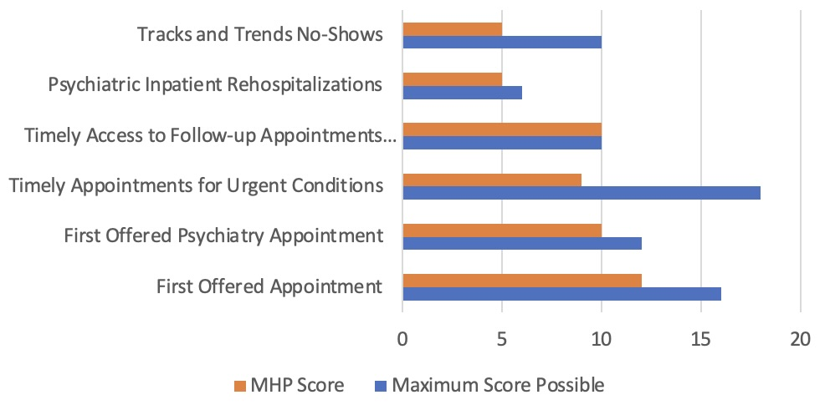

Source: Sacramento County MHP Cal EQRO Report FY 2020-21

The Mental Health Plan (MHP) for Sacramento County does not track no-shows/cancellations separately for clinicians and psychiatrists. The Assessment of Timely Access does not indicate whether the information reported was for the entire system or just directly operated providers. The MHP reports a no-show rate of less than 0.1 percent. The Sacramento Benchmarks document for CY 2019 shows no-show rates between 7.6 percent and 13.3 percent depending on the age group of the beneficiaries. It is unclear why these two measures are so different. Reported timeliness data for this metric did not separate adults and older adults.

The MHP reported a rehospitalization rate of 22 percent based on CY 2019 data. The EQRO Performance Measures reports a rehospitalization rate of 1 percent. It is unclear why the two reports are so different. EQRO queried if the MHP’s reported 22 percent might reflect all subsequent hospitalizations versus 11 being only the first re-hospitalization. The MHP reported a rehospitalization rate for adults at 23.3 percent, for children at 2.5 percent, and for foster care (FC) at 30 percent. Reported timeliness data for this metric did not separate adults and older adults.

The MHP standard for follow-up post psychiatric hospitalization is the Healthcare Effectiveness Data and Information Set (HEDIS) standard of seven days. The standard was met 71.8 percent of the time overall, 70.7 percent for adults, 83.6 percent for children, and 88.9 for FC. The 7-day standard for post-hospital follow-up appointments was met 71.8 percent of the time overall in FY 2019-20. The EQRO Performance Measure for CY 2019 shows a rate of 50 percent for 7-day follow-up, which was an improvement from CY 2018 (at 29 percent). It is unclear why these two reports are inconsistent. There has clearly been a significant improvement in this measure. Again, reported timeliness data for this metric did not separate adults and older adults.

The Department of Healthcare Services (DHCS) standard for length of time from service request for urgent appointment to actual encounter is 48 hours for appointments that do not require prior authorization and 96 hours for appointments that require prior authorization. The MHP is determining the method to track these requests. With the implementation of the MHUCC, all calls for urgent or crisis services are directed to the MHUCC. The MHUCC also serves walk-in beneficiaries and those who are brought by law enforcement. The 96-hour standard for urgent appointments requiring an authorization does not apply because the MHP does not require authorization for urgent requests for services. Reported timeliness data for this metric was not reported.

The MHP standard from initial request to first offered psychiatry appointment is 15

days. The standard was met 97.7 percent of the time overall, 98 percent for adults, 96.2 percent for children, and 100 percent for FC. The data are part of a timeliness assessment provided post review and takes into account new ways to track this data. As in the above circumstances, reported timeliness data for this metric did not separate adults and older adults.

The MHP has a standard of ten business days in compliance with the state timeliness metric. They meet this standard 100 percent of the time overall, including adults, children, and FC. Time to first offered and first kept appointment is defaulted to the date and time of the call, as that is when the Access Line employee delivers the brief assessment, rather than at first accepted and kept appointment. Once again, timeliness data were not separated for adults and older adults.

**Recommendations:**

The External Quality Review Organization (EQRO) for Medi-Cal Specialty Mental Health made the following recommendations relating to timeliness of services in its FY 2020-21 Report, which are repeated here:

Recommendation 1: Review with DHCS the method currently used to measure the

time to first offered and first kept appointment, which has resulted in meeting the

standard 100 percent of the time. Also review whether the time to the second

clinical appointment is at or near 100 percent.

Recommendation 2: Continue efforts to recruit and retain adequate psychiatry

coverage and measure progress in terms of full-time equivalents (FTEs) and time

to first psychiatry appointment.

Recommendation 3: Begin to track and report no-shows separately for

psychiatrists and clinicians. Disaggregate data for adults, older adults, children,

and youth in foster care (FC).

Recommendation 4: Determine a methodology to track time to response for urgent conditions and implement. Track and report this data, disaggregating adults, older adults, children, and FC.

# Crisis Services

# Dignity Health Mercy San Juan Outpatient Behavioral Health Crisis Services Collaborative (CSU)

The Dignity Health Mercy San Juan Outpatient Behavioral Health Crisis Services Collaborative (CSU) serves individuals eighteen years of age and older for an average of 23 hours when they present to Dignity Health’s Mercy San Juan Emergency Department, experiencing a mental health crisis, are medically stabilized, and would benefit from mental health and crisis stabilization services. The program has an expressed goal of reducing the number of involuntary 5150 holds and transfers to inpatient psychiatric units, and states that it has successfully discharged 75% of its patients home who otherwise would have remained waiting for services. The program began operating in September 2019. CSU has increased its patient volume from its start in 2019 to just under 200 per month in early FY2022. Dignity Health’s data relating to the program through mid 2022 relating to volume and racial / ethnic diversity follow in Figures 12 and 13 below.

Figure 12: CSU Volume

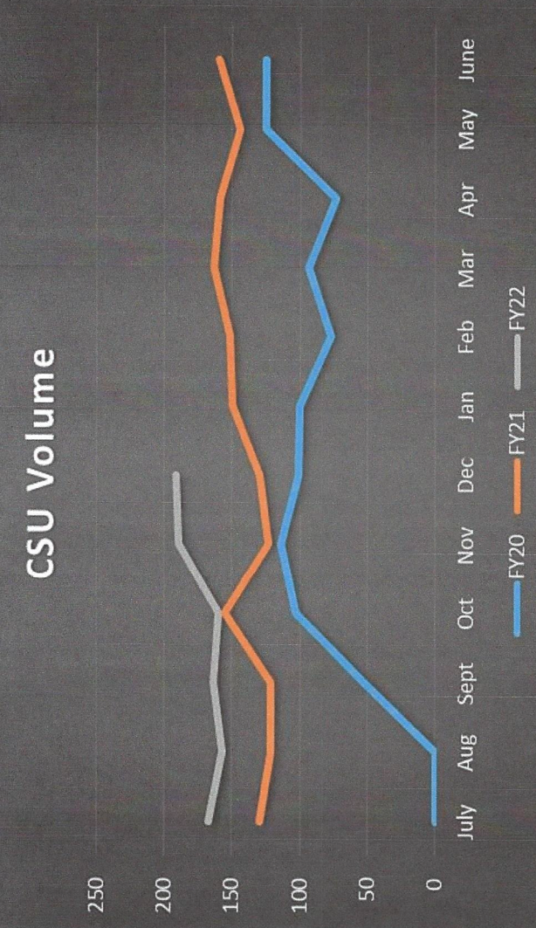

Source: Dignity Health, MSJ OP Behavioral Health Crisis Services Collaborative (CSU)

A comparison of CSU demographics to US Census data for Sacramento County reflects significant underrepresentation of clients who identify as Asian race or Hispanic ethnicity.

Figure 13: Diversity in the CSU

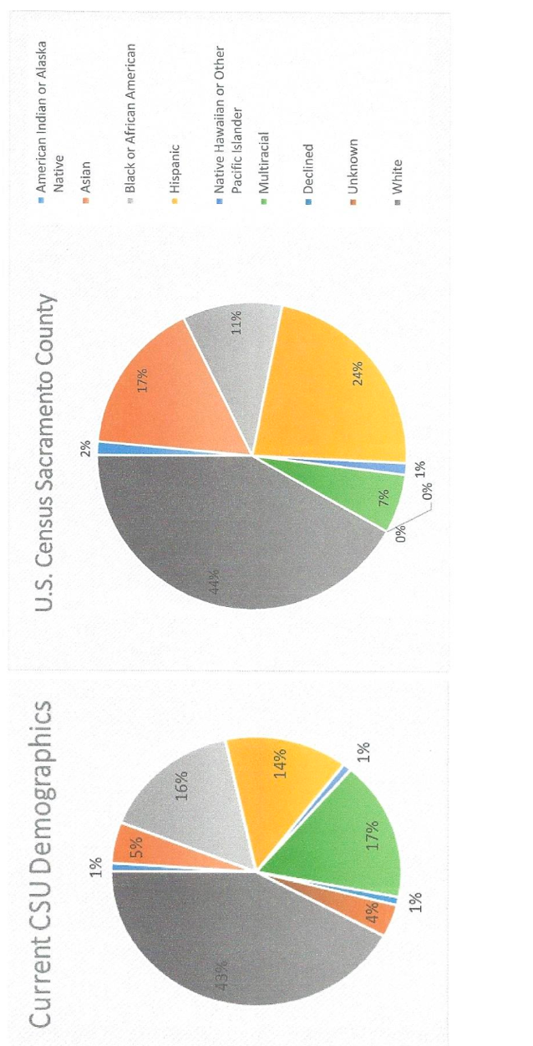

Source: Dignity Health, MSJ OP Behavioral Health Crisis Services Collaborative (CSU)

**Recommendation:**

Behavioral Health Services should investigate the reasons for the underrepresentation of clients of Asian race and Hispanic ethnicity treated at CSU.

# Mental Health Urgent Care Center (MHUCC)

The Mental Health Urgent Care Center (MHUCC) was funded by the Mental Health Services Act (MHSA) and SB 82 Mental Health Wellness Grant, and is contracted with Turning Point Community Programs. It provides services 24 hours per day / 7 days per week on a voluntary basis, including walk-ins during open hours of operation, to Sacramento County residents who are experiencing a mental health and/or co-occurring substance abuse crisis, regardless of ability to pay. It is an alternative to emergency departments for those in crisis or experiencing an urgent mental health need and seeking mental health care. Services provided include: psychiatric medication evaluation (excluding controlled substances), integrated co-occurring mental health and substance abuse crisis assessment, crisis intervention and problem solving to avoid the need for inpatient hospitalization, referral and linkage to ongoing services and community supports, and peer and family support.[4]

**Community Wellness Response Team (CWRT)**

The Community Wellness Response Team (CWRT) was funded in 2022 as a response to the community demand for an alternative to law enforcement in emergency situations. Formerly known as the Wellness Crisis Call Center and Response Team (WCCCRT), its Program Description follows in Figure 14 below:

Figure 14:

**Division of Behavioral Health**

**Wellness Crisis Call Center and Response Team**

**PROGRAM DESCRIPTION[5]**

Sacramento’s Behavioral Health Services (BHS) includes services that meet the cultural, ethnic and language needs of the community and promotes health and wellness; resilience, wellbeing, and healing from traumatic experiences; prevention, support, and treatment for mental health and/or substance use challenges; and support of those who experience and/or are in recovery from these conditions, along with their families and communities.

**Program Summary:**

The Wellness Crisis Call Center and Response Team (WCCCRT) receives calls from community members requesting behavioral health services or when they are experiencing a mental health crisis. Clinicians and staff with lived experience can be dispatched to respond immediately to locations throughout the County. These Call Center and Response Teams staff provide immediate, 24/7 crisis intervention and deescalation services, assess needs and risks, and create safety plans. This includes identifying and leveraging individual strengths and natural supports; coordinating with existing Mental Health Plan (MHP) and Substance Use Prevention and Treatment (SUPT) providers as appropriate; linking to services; voluntary transport to urgent/emergency resources and accessing alternate response teams or emergency responders when necessary.

**WCCCRT Goals:**

• Safely de-escalate crises

• Provide linkages to accessible culturally responsive behavioral health resources to

decrease repeat crises and emergency department visits

• Offer a response team that meets the cultural, ethnic and language needs of the

community and does not include law enforcement staffing

• Ensure the model is community-based

• Decrease criminalization of mental health and homelessness

**Recommendation:**

Behavioral Health Services should take steps to improve data gathering and follow up relative to age, gender, gender identity, sexual orientation, race, ethnicity, and primary language relating to its clients at the crisis services locations identified above, in order to improve such services to underserved population groups.

# Capacity of Services

Capacity was discussed with the External Quality Review Organization (EQRO)[6], and the 2019-20 report noted that the “MHP continues to lack program capacity to service beneficiary demand for services.”

As of March 9, 2023, Behavioral Health Services has 21 on-call and 25 permanent Mental Health Counselor positions vacant. These quantities translate to a 42% vacancy rate for Mental Health Counselors. Additionally, BHS currently has 23 on-call and 47 permanent Senior Mental Health Counselor positions vacant. These quantities translate to a 33% vacancy rate for Senior Mental Health Counselors.

Sacramento County employs Mental Health Counselors and Senior Mental Health Counselors in existing behavioral health programs such as the Intake Stabilization Unit (ISU) of the Mental Health Treatment Center and the Mobile Crisis Support Team, and Senior Mental Health Counselors are employed in new Behavioral Health Services programs such as the Community Wellness Response Team. Additionally, Mental Health Counselors and Senior Mental Health Counselors are employed in Sacramento County Probation Department’s Adult Day Reporting Centers.

The vacancies for mental health counselors and senior mental health counselors are concentrated in a majority of Behavioral Health Services programs that are utilized for acute and crisis levels of care, such as the Mental Health Treatment Center, the Mobile Crisis Support Team, the Community Wellness Response Team, and the Adult Day Reporting Centers. These programs are also part of Sacramento County’s Jail Population Reduction Plans, approved by the Sacramento County Board of Supervisors on December 7, 2022 in response to Mays Consent Decree requirements.

For example, the Mental Health Treatment Center’s Intake Stabilization Unit has a 37.5% vacancy rate and its Psychiatric Health Facility has a 20% vacancy rate for mental health counselors and senior mental health counselors. The Community Wellness Response Team has an 85% vacancy rate for mental health counselors and 100% vacancy rate for Senior Mental Health Counselors. The Adult Day Reporting Center has a 66% vacancy rate, and the Assisted Outpatient Treatment Program has a 50% vacancy rate for these positions. Likewise, the Mobile Crisis Support Team has a 36.3% vacancy rate for mental health counselors and senior mental health counselors.

The vacancies described above diminish capacity of services and negatively impact staff demographic compatibility with the beneficiaries served.

Creative solutions by private sector organizations to address the behavioral health workforce crisis include more flexibility for remote work, paid time off systems, and four-day work weeks. In states where the cost of living is high, salaries play a significant role in decision-making. Behavioral health professionals are being recruited by private organizations offering higher pay and flexible work schedules, both of which promote greater mental health for its workers. These positions are attractive because the financial compensation offered is at a level reflecting their demand within the behavioral health care system. For example, the starting hourly wage for a licensed mental health professional with Kaiser Permanente in Northern California is $52.87. Additionally, the starting hourly wage for a non-licensed, Master’s level mental health professional with Kaiser Permanente in Northern California is $44.75. Comparatively, Behavioral Health Services offers $45.71 per hour for the senior mental health counselor position and $36.86 for the mental health counselor position, differences of between $7 and $8 per hour.

**Recommendation:**

The Board of Supervisors should work to increase the funding of the Division of Behavioral Health Services so it has greater capacity to provide services by:

* Maximizing the allocation of County General Funds to the Division of Behavioral Health Services.
* Working through its lobbyist and the California State Association of Counties to advocate for more funding for community behavioral health services in the state budget, including realignment funds and Medi-Cal.
* Approving additional compensation for Mental Health Counselors and Senior Mental Health Counselors to be more competitive with the private sector and reduce the vacancy rate.

# Penetration Rates

The penetration rate is the percentage of Medi-Cal beneficiaries utilizing services out of the total number of Medi-Cal eligible beneficiaries. Penetration rates for CY 2017 and 2018 and CY 2020 and 2021 are shown in Tables 5 and 6 below.

Table 5: Penetration Rates CY 2017, CY 2018



Table 6: Penetration Rates CY 2020, CY 2021

Medi-Cal Eligible Beneficiaries – EQRO claims data

MHP Medi-Cal Beneficiaries – Sacramento County Behavioral Health Electronic Health Record data



Overall penetration rates decreased between CY 2017 and 2018, with some variation among age and racial groups. The recommendation made at the time of the March 2021 report was that Behavioral Health Services should investigate the causes of the decrease in penetration rates for 0 to 5 year olds, 6 to 17 year olds, African Americans, and clients who identify as belonging to Other racial groups.

The penetration rates continued to show slight decreases among most age and racial groups between CY 2018 and 2020.

Between CY 2020 and 2021, there were significant, greater than 5%, decreases in overall penetration rates among ages 0-5 and 18-59, males, and White, American Indian / Alaskan Native, and clients who identify as belonging to Other racial groups. The latter Other racial group is particularly significant in that the decrease in penetration rate exceeded 20%, which was also noted in CY 2018. None of the other decreases were greater than 8.3%.

**Recommendation:**

Behavioral Health Services should investigate the causes of the decrease in penetration rate for clients who identify as belonging to Other racial groups. The great disparity between the latter penetration rate and the penetration rates for all other groups reflects the critical need for focus on clients identifying in the Other racial group. Behavioral Health Services should consider targeted outreach to persons who identify as Other racial group. Behavioral Health Services should add and maintain penetration rate data relating to primary language.

# Retention Rates

There is relative consistency in retention rates across most race, age, and sex groups, with two notable exceptions. Persons of unknown or unreported race have a retention rate for greater than 15 services that is 10% to 20% lower than almost all defined racial groups. This trend reappears when primary language is unknown or unreported, by 30% to 40% lower than almost all specified languages. There are two other primary language groups with a significantly lower retention rate, by 10% to 20%, for greater than 15 services: Arabic and Other. The March 2021 report also noted the disparity relating to persons speaking Arabic languages at that time.

Retention rates for FY 2021-22 are shown in Table 7 below.

Table 7: Retention

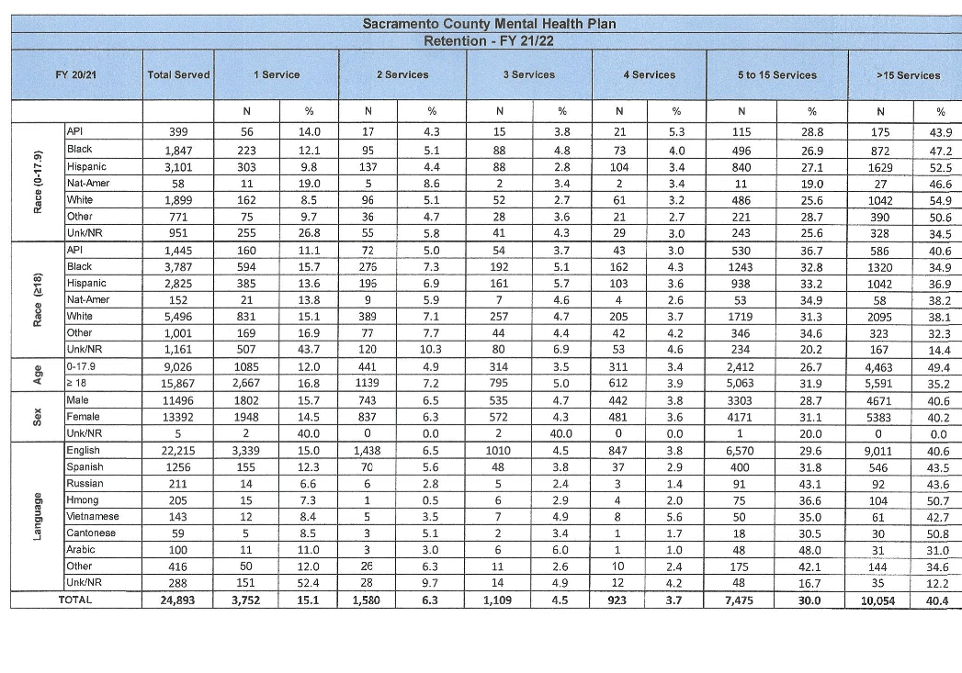

**Recommendation:**

Behavioral Health Services should take steps to improve data gathering and follow up relative to age, gender, gender identity, sexual orientation, ethnicity, race, and primary language relating to retention, especially for greater than 15 services. In addition, Behavioral Health Services should investigate the causes of the disparity in retention rate for clients whose primary language is Arabic or Other, and then implement changes aimed at improving their retention.

# Human Resources

As stated in the 2019 Human Resources Survey report, counties are required to collect demographic information and language capabilities of staff, volunteers, and any committee members who participate in serving individuals throughout the entire County Mental Health System. The purpose of the survey was to assess demographic and linguistic information for those who provide services in the county to determine whether they are reflective of the diversity of the community as a whole. Following the survey, additional data was gathered comparing direct service staff to Medi-Cal beneficiary clients served in the Mental Health Plan relating to gender, sexual orientation, race, and primary language for FY 2019-20, the results of which are shown below:

**“Direct Services Staff Compared to Clients Served in the Mental Health Plan (MHP)**

“The data below compares direct service staff gender and race with the gender and race of Medi-Cal beneficiaries served in the MHP during Fiscal Year 19-20. Note: Not all demographics collected on the HR survey are comparable to the clients served, due to the way in which the data was collected.

**“Gender**

“As indicated below, males are underrepresented in direct service staff, compared to the number of males served in the system.

Figure 15:

**“Sexual Orientation**

“As indicated below, almost half of the beneficiaries are unknown or not reported.

Figure 16:

**“Race**

“In regards to race, African American and Caucasian Direct Service Staff are underrepresented, compared to the number of African American and Caucasian clients served, while Asian/Pacific Islander, Hispanic and Other Direct Service Staff are overrepresented.

Figure 17:

“**Language**

“While the MHP has a wide variety of languages spoken by staff, the percent who speak the Sacramento County threshold languages is lower than the beneficiaries served, with the exception of “Other Non-English” languages.

Figure 18:

Source (Quoted Text & Figures 11-14): Sacramento County Mental Health Division of Behavioral Health Services

### Summary:

As stated in the 2021 Report, in general Behavioral Health Services has a diverse staff in terms of race and language diversity among direct service staff. However, some imbalances still exist when current staffing levels are compared to the Medi-Cal beneficiary population for males, White and African American race groups, and several primary languages, most notably Hmong and Russian. In addition, a little over 80% of Medi-Cal MHP beneficiaries declined to state or otherwise went unreported regarding sexual orientation.

**Recommendation:**

Renewing the recommendation made in the 2021 Report, Behavioral Health Services should strive in its recruitment efforts to ameliorate the imbalances that exist in its representation of staff by gender, gender identity, sexual orientation, race, and primary language. In addition, Behavioral Health Services should take steps to improve data gathering and follow up relative to sexual orientation from Medi-Cal MHP beneficiaries in order to assure adequate staff representation for various sexual orientations.

1. <https://dhs.saccounty.gov/BHS/Documents/Advisory-Boards-Committees/Mental-Health-Services-Act-Committee/MHSA-SC-2021/MA-MHSA-SC-2021-02-18--ATT-C-Sacramento-County-EQRO-Final-Report-Summary-FY20-21.pdf>
2. <https://www.behealthysacramento.org/indexsuite/index/mentalhealth?localeType=3&parentLocale=271&periodId=246>
3. <https://dhs.saccounty.gov/BHS/Documents/Reports--Workplans/RT-EQRO-Report-FY2020-21.pdf>
4. <https://www.tpcp.org/program/urgent-care/>
5. <https://dhs.saccounty.gov/BHS/SiteAssets/Pages/Community-Wellness-Response-Team/CWRT%20Program%20Description%20-%20Final%20Updated%206.12.23.pdf>
6. The EQRO conducts reviews of MHPs to analyze and evaluate information related to quality, timeliness, and access to SMHS provided by California's 56 MHPs and/or their subcontractors to Medi-Cal beneficiaries. California EQRO for the Medi-Cal SMHS Program is Behavioral Health Concepts (BHC), Inc.