Table of Contents
Enhanced Care Management (ECM) 3
Source: Enhanced Care Management (ECM) Implementation Data from CY 2022 3
Sacramento Data 3
1) Number of MCP members, potentially eligible, and received ECM in CY 2022 3
2) Penetration rates (in percentages) in Sacramento 4
3) Penetration rates (in percentages) by Managed Care Plans (MCPs) 4
4) Penetration rates (in percentages) by Managed Care Plans (MCPs) and Population of Focus (PoF) Out of All Members that Received ECM 5
5) Penetration rates (in percentages) by Managed Care Plans (MCPs) and Population of Focus (PoF) Out the Total of MCP Members 7
Comparison Data Q1-Q3 2023 vs CY 2022 9
1) Penetration Rate (in percentages) by Managed Care Plans (MCPs) and Population of Focus (PoF) In Q1-Q3 2022 9
2) Penetration Rate (in percentages) by Managed Care Plans (MCPs) and Population of Focus (PoF) in Calendar Year 2022 11
3) Rate of change (in percentages) by Managed Care Plans (MCPs) and Population of Focus (PoF) 12
4) Penetration Rate and Percentage Point Difference by Managed Care Plans (MCPs) and Population of Focus (PoF) 13
Comparison Data to Similar Counties (Out of All Members that Received EMC) 14
1) Penetration rates (in percentages) of counties with MCP members near/close in size to Sacramento members 14
2) Penetration rates (in percentages) more than 1% by counties 15
3) Penetration rates (in percentages) more than 1% by counties and health plan/MCP 16
4) Penetration rates (in percentages) by counties and population of focus 17
Community Supports (CS) 18
Source: Community Supports (CS) Implementation Data from CY 2022 18
Sacramento Data 18
1) Number of MCP members provided and received CS Services in CY 2022, including penetration rate (in percentages) 18
2) Penetration rates (in percentages) by Managed Care Plans (MCPs) 19
3) Penetration rates (in percentages) of CS services members received by Managed Care Plans (MCPs) 21
Aetna Better Health of California 21
Anthem Blue Cross 21
Health Net Community Solutions 21
Kaiser Permanente 21
Molina Healthcare of California 21
4) CS services rates (in percentages) by Managed Care Plans (MCPs) and by housing services 22
Comparison Data Q1-Q3 2023 vs CY 2022 23
1) Rate of change (in percentages) by Managed Care Plans (MCPs) and by housing services 23
2) Penetration Rate and Percentage Point Difference by Managed Care Plans (MCPs) and by housing services 24
3) Baseline data for Public Health CHIP SMART Goal 24
Comparison Data to Similar Counties 26
1) Number of MCP members provided and received CS Services in CY 2022, including penetration rate (in percentages) near/close in member size as to Sacramento 26
2) Comparable counties with MCP members who received CS services near/close in number to Sacramento members 26
3) CS services by comparable counties as Sacramento and by housing services (Note: Housing services is categorized by DHS not by DHCS) 27
4) CS services by Managed Care Plans (MCPs) in Sacramento and San Diego counties by housing services 27
5) CS services rates (in percentages) by Managed Care Plans (MCPs) in Sacramento and San Diego counties by housing services 28

Enhanced Care Management (ECM)

Source: Enhanced Care Management (ECM) Implementation Data from CY 2022
Note:
- A member who received ECM in multiple counties or from multiple MCPs due to a relocation or plan change in 2022 may be counted multiple times in this report.
- A member can be eligible for and counted in multiple POFs. Post-processing, the terms “provided” or “eligible” are used interchangeably.
- To comply with data privacy standards, data points with a value under 11 at the plan level are suppressed and reported as <11. Post-processing by DHS reported the “<11” values as “11.”
  - Data points at the county level that are under 11 or are greater than 10 but could be used to deduce a masked plan-level value are reported as *. Rates that could be used to deduce a masked value are reported as *.
- Additional resource, Enhanced Care Management Fact Sheet

Sacramento Data

1) Number of MCP members, potentially eligible, and received ECM in CY 2022
Note:
Per the state: "While DHCS expects that 3-5% of Medi-Cal membership will be eligible for ECM, this will vary based off of local demographics and not all eligible members may want to participate in the program, so penetration rates are expected to be significantly lower than 3-5%. There are no explicit targets for ECM penetration rates at this time, only baseline trends which will evolve as more data is collected."
The ‘Potentially Eligible for ECM” is not part of the original data table published by DHCS. Post-processing, it is an estimated calculation of 4% of the total number of members who are eligible for EMC.

2) Penetration rates (in percentages) in Sacramento

3) Penetration rates (in percentages) by Managed Care Plans (MCPs)
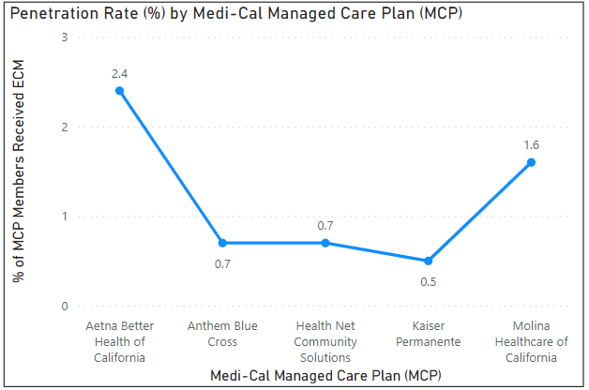
Counties | Managed Care Plan (MCP) | Total MCP Members | Total MCP Members Received ECM | (%) of MCP Members Who Received ECM
Sacramento |  | 532,691 | 4,380 | 0.8%
Sacramento | Aetna Better Health of California | 20,197 | 477 | 2.4%
Sacramento | Anthem Blue Cross | 211,416 | 1,516 | 0.7%
Sacramento | Health Net Community Solutions | 129,908 | 944 | 0.7%
Sacramento | Kaiser Permanente | 113,477 | 516 | 0.5%
Sacramento | Molina Healthcare of California | 57,085 | 930 | 1.6%

Across the MCPs, less than 2.5% of all members (eligible or ineligible for EMC) received ECM. Across 3 of the 5 plans, less than 1% of members received
ECM in CY 2022.

4) Penetration rates (in percentages) by Managed Care Plans (MCPs) and Population of Focus (PoF) Out of All Members that Received ECM
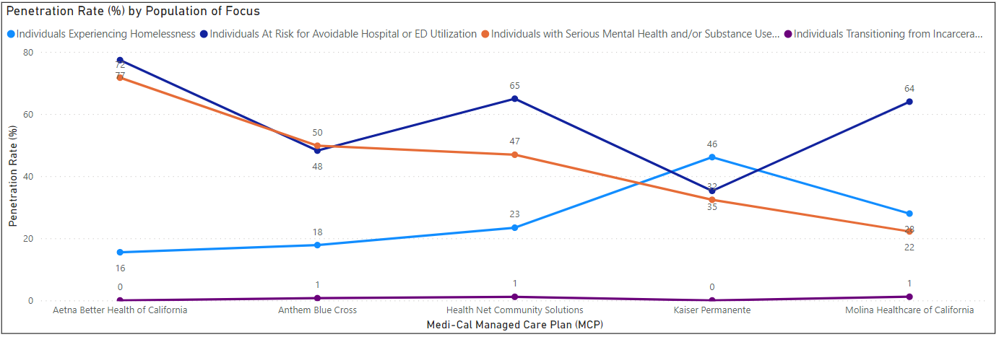
Counties | Medi-Cal Managed Care Plan (MCP) | Total Members Who Received ECM | Individuals Experiencing Homelessness | Penetration Rate (% of MCP Members Received ECM Individuals Experiencing Homelessness | Individuals At Risk for Avoidable Hospital or ED Utilization | Penetration Rate (% of MCP Members Received ECM Individuals At Risk for Avoidable Hospital or ED Utilization | Individuals w/Serious Mental Health and/or Substance Use Disorder Needs | Penetration Rate (% of MCP Members Received ECM Individuals w/Serious Mental Health and/or Substance Use Disorder Needs | Individuals Transitioning from Incarceration | Penetration Rate (% of MCP Members Received ECM Individuals Transitioning from Incarceration
Sacramento | Aetna Better Health of California | 477 | 74 | 16% | 369 | 77% | 342 | 72% | 0 | 0%
Sacramento | Anthem Blue Cross | 1,516 | 270 | 18% | 731 | 48% | 755 | 50% | 11 | 1.0%
Sacramento | Health Net Community Solutions | 944 | 221 | 23% | 613 | 65% | 443 | 47% | 11 | 1.2%
Sacramento | Molina Healthcare of California | 930 | 260 | 28% | 595 | 64% | 206 | 22% | 11 | 1.1%
Sacramento | Kaiser Permanente | 516 | 238 | 46% | 182 | 32% | 167 | 35% | 0 | 0%

5) Penetration rates (in percentages) by Managed Care Plans (MCPs) and Population of Focus (PoF) Out the Total of MCP Members
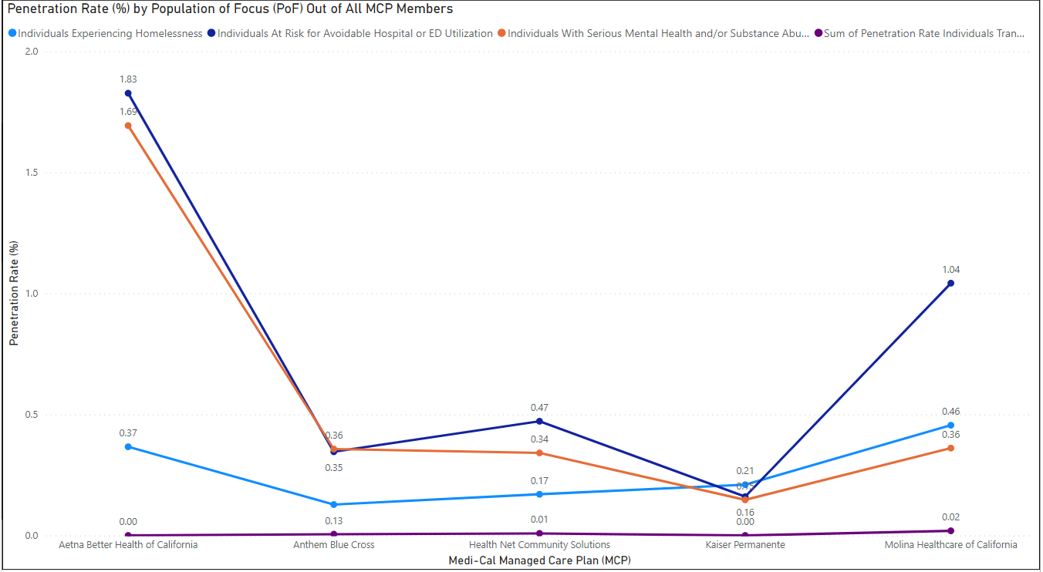
Counties | Medi-Cal Managed Care Plan (MCP) | Total MCP Members | Individuals Experiencing Homelessness | Penetration Rate (% of MCP Members Individuals Experiencing Homelessness) | Individuals At Risk for Avoidable Hospital or ED Utilization | Penetration Rate (% of MCP Members Individuals At Risk for Avoidable Hospital or ED Utilization) | Individual w/ Serious Mental Health and/or Substance Use Disorder Needs | Penetration Rate (% of MCP Members Individuals w/ Serious Mental Health and/or Substance Use Disorder Needs) | Individuals Transitioning from Incarceration | Penetration Rate (% of MCP Members Individuals Transitioning from Incarceration)
Sacramento | Aetna Better Health of California | 20,197 | 74 | 0.37% | 369 | 1.83% | 342 | 1.69% | 0 | 0.00%
Sacramento | Anthem Blue Cross | 211,416 | 270 | 0.13% | 731 | 0.35% | 755 | 0.36% | 11 | 0.01%
Sacramento | Health Net Community Solutions | 129,908 | 221 | 0.17% | 613 | 0.47% | 443 | 0.34% | 11 | 0.01%
Sacramento | Kaiser Permanente | 113,477 | 238 | 0.21% | 182 | 0.16% | 167 | 0.15% | 0 | 0.00%
Sacramento | Molina Healthcare of California | 57,085 | 260 | 0.46% | 595 | 1.04% | 206 | 0.36% | 11 | 0.02%

Comparison Data Q1-Q3 2023 vs CY 2022

1) Penetration Rate (in percentages) by Managed Care Plans (MCPs) and Population of Focus (PoF) In Q1-Q3 2023
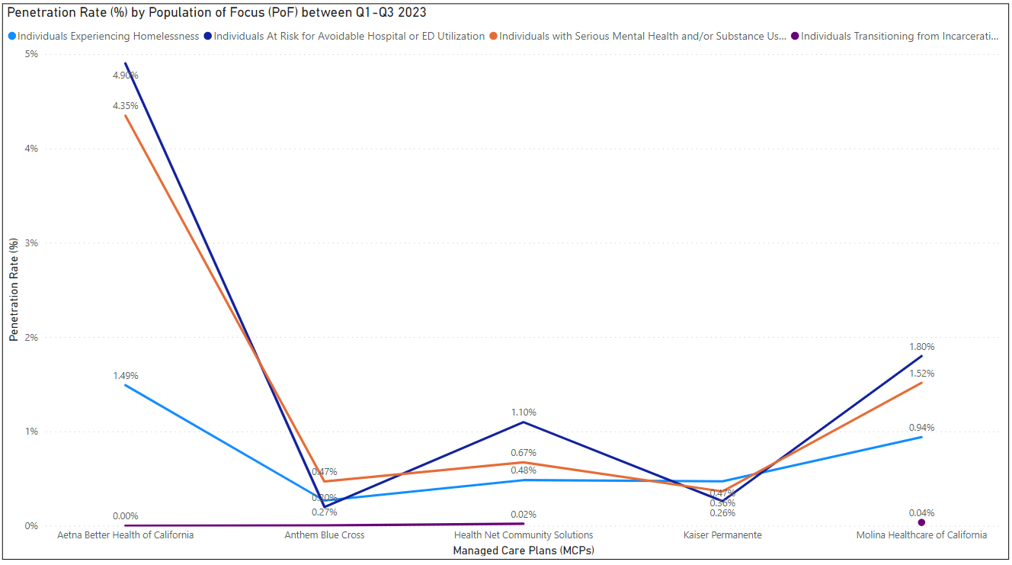
Managed Care Plans (MCPs) | Q1-Q3 2023 Individuals Experiencing Homelessness | Penetration Rate (% of Individuals Experiencing Homelessness Members in Q1-Q3 2023 Out of All Total Members in 2022) | Q1-Q3 2023 Individuals At Risk for Avoidable Hospital or ED Utilization | Penetration Rate (% of Individuals At Risk for Avoidable Hospital or ED Utilization Members in Q1-Q3 2023 Out of All Total Members in 2022) | Q1-Q3 2023 Individuals with Serious Mental Health and/or Substance Use Disorder Needs | Penetration Rate (% of Individuals with Serious Mental Health and/or Substance Use Disorder Needs inQ1-Q3 2023 Out of All Total Members in 2022) | Q1-Q3 2023 Individuals Transitioning from Incarceration | Penetration Rate (% of Individuals Transitioning from Incarceration in Q1-Q2 2023 Out of All Total Members in 2022) | Total MCP Members in CY 2022
Aetna Better Health of California | 301 | 1.49% | 990 | 4.90% | 878 | 4.35% | 0 | 0.00% | 20,197
Anthem Blue Cross | 564 | 0.27% | 419 | 0.20% | 993 | 0.47% | 7 | 0.00% | 211,416
Health Net Community Solutions | 628 | 0.48% | 1427 | 1.10% | 873 | 0.67% | 27 | 0.02% | 129,908
Kaiser Permanente | 534 | 0.47% | 296 | 0.26% | 413 | 0.36% | N/A | N/A | 113,477
Molina Healthcare of California | 536 | 0.94% | 1027 | 1.80% | 865 | 1.52% | 20 | 0.04% | 57,085

2) Penetration Rate (in percentages) by Managed Care Plans (MCPs) and Population of Focus (PoF) in Calendar Year 2022
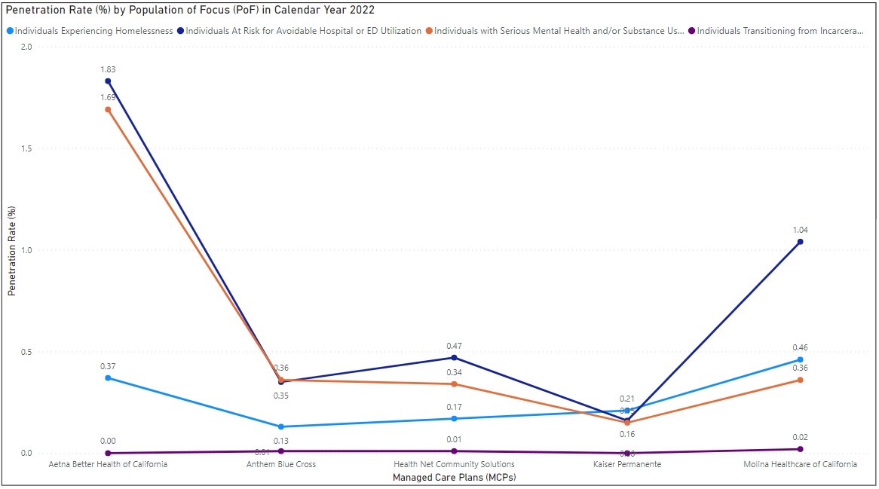
Managed Care Plans (MCPs) | CY 2022 Individuals Experiencing Homelessness | Penetration Rate (% of Individuals Experiencing Homelessness Members in CY 2022 Out of All Total Members in 2022) | CY 2022 Individuals At Risk for Avoidable Hospital or ED Utilization | Penetration Rate (% of Individuals At Risk for Avoidable Hospital or ED Utilization Members in CY 2022 Out of All Total Members in 2022) | CY 2022 Individuals with Serious Mental Health and/or Substance Use Disorder Needs | Penetration Rate (% of Individuals with Serious Mental Health and/or Substance Use Disorder Needs in CY 2022 Out of All Total Members in 2022) | CY 2022 Individuals Transitioning from Incarceration | Penetration Rate (% of Individuals Transitioning from Incarceration in CY 2022 Out of All Total Members in 2022) | Total MCP Members in CY 2022
Aetna Better Health of California | 74 | 0.37% | 369 | 1.83% | 342 | 1.69% | 0 | 0.00% | 20,197
Anthem Blue Cross | 270 | 0.13% | 731 | 0.35% | 755 | 0.36% | 11 | 0.01% | 211,416
Health Net Community Solutions | 221 | 0.17% | 613 | 0.47% | 443 | 0.34% | 11 | 0.01% | 129,908
Kaiser Permanente | 238 | 0.21% | 182 | 0.16% | 167 | 0.15% | 0 | 0.00% | 113,477
Molina Healthcare of California | 260 | 0.46% | 595 | 1.04% | 206 | 0.36% | 11 | 0.02% | 57,085

3) Rate of change (in percentages) by Managed Care Plans (MCPs) and Population of Focus (PoF)
Population of Focus (PoF) | Aetna Better Health of California |  |  | Anthem Blue Cross |  |  | Health Net Community Solutions |  |  | Kaiser Permanente |  |  | Molina Healthcare of California
 | Q1 - Q3 2023 | CY 2022 | % Change | Q1 - Q3 2023 | CY 2022 | % Change | Q1 - Q3 2023 | CY 2022 | % Change | Q1 - Q3 2023 | CY 2022 | % Change | Q1 - Q3 2023 | CY 2022 | % Change
Individuals Experiencing Homelessness | 301 | 74 | 306.8 | 564 | 270 | 108.9 | 628 | 221 | 184.2 | 534 | 238 | 124.4 | 536 | 260 | 106.1
Individuals At Risk for Avoidable Hospital or ED Utilization | 990 | 369 | 168.3 | 419 | 731 | -42.7 | 1427 | 613 | 132.8 | 296 | 182 | 62.6 | 1027 | 595 | 72.6
Individuals with Serious Mental Health and/or Substance Use Disorder Needs | 878 | 342 | 156.7 | 993 | 755 | 31.5 | 873 | 443 | 97.1 | 413 | 167 | 147.3 | 865 | 206 | 319.9
Individuals Transitioning from Incarceration | 0 | 0 | 0 | 7 | 11 | -36.4 | 27 | 11 | 145.5 | N/A | 0 | N/A | 20 | 11 | 81.8

Example of Percent (%) Change Calculation (to reference above)
Quantity | Value | Outcome
Q1-Q3 2023 number |  | 301
CY 2022 number |  | 74
Difference | 301-74 | 227
Ratio of difference to CY 2022 | 227/74 | 3.07
Ratio multiplied by 100 | 3.07*100 | 306.8

4) Penetration Rate and Percentage Point Difference by Managed Care Plans (MCPs) and Population of Focus (PoF)
Population of Focus (PoF) | Aetna Better Health of California |  |  | Anthem Blue Cross |  |  | Health Net Community Solutions |  |  | Kaiser Permanente |  |  | Molina Healthcare of California
 | Q1 - Q3 2023 | CY 2022 | Point Change | Q1 - Q3 2023 | CY 2022 | Point Change | Q1 - Q3 2023 | CY 2022 | Point Change | Q1 - Q3 2023 | CY 2022 | Point Change | Q1 - Q3 2023 | CY 2022 | Point Change
Individuals Experiencing Homelessness | 1.49% | 0.37% | 1.12 | 0.27% | 0.13% | 0.14 | 0.43% | 0.17% | 0.26 | 0.47% | 0.21% | 0.26 | 0.94% | 0.46% | 0.48
Individuals At Risk for Avoidable Hospital or ED Utilization | 4.90% | 1.83% | 3.07 | 0.20% | 0.35% | -0.15 | 0.32% | 0.47% | -0.15 | 0.26% | 0.16% | 0.10 | 1.80% | 1.04% | 0.76
Individuals with Serious Mental Health and/or Substance Use Disorder Needs | 4.35% | 1.69% | 2.65 | 0.47% | 0.36% | 0.11 | 0.76% | 0.34% | 0.42 | 0.36% | 0.15% | 0.22 | 1.52% | 0.36% | 1.15
Individuals Transitioning from Incarceration | 0 | 0 | 0 | 0.00% | 0.01% | 0 | 0.01% | 0.01% | 0 | N/A | 0 | N/A | 0.04% | 0.02% | 0.02
Total MCP Members in CY 2022 | 20,197 |  |  | 211,416 |  |  | 129,908 |  |  | 113,477 |  |  | 57,085

Comparison Data to Similar Counties (Out of All Members that Received EMC)

1) Penetration rates (in percentages) of counties with MCP members near/close in size to Sacramento members
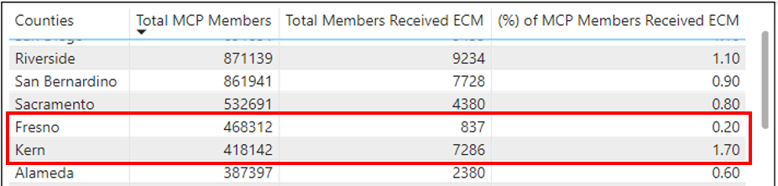
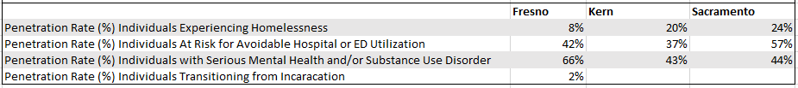
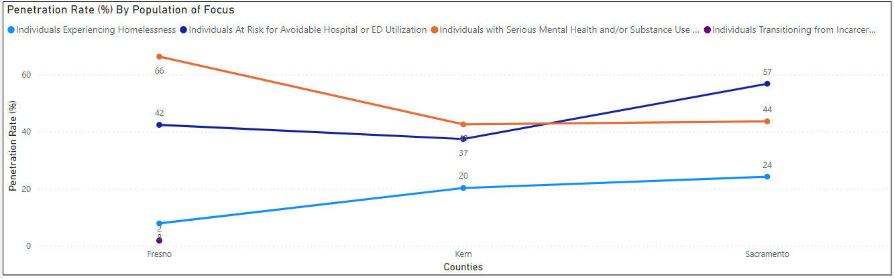

2) Penetration rates (in percentages) more than 1% by counties
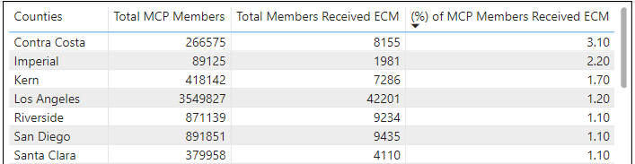

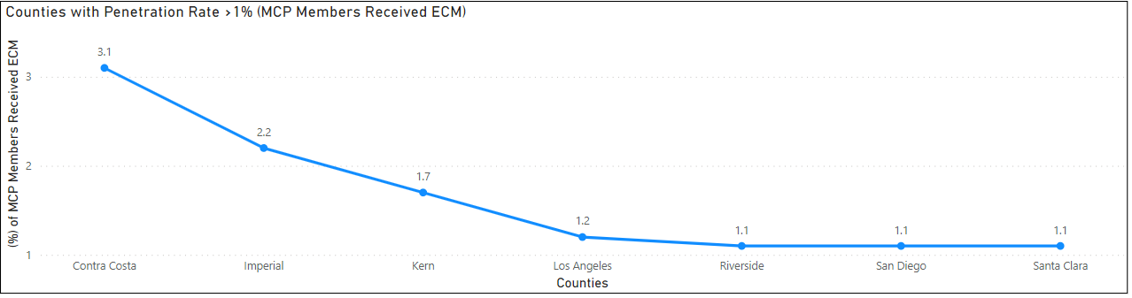

3) Penetration rates (in percentages) more than 1% by counties and health plan/MCP
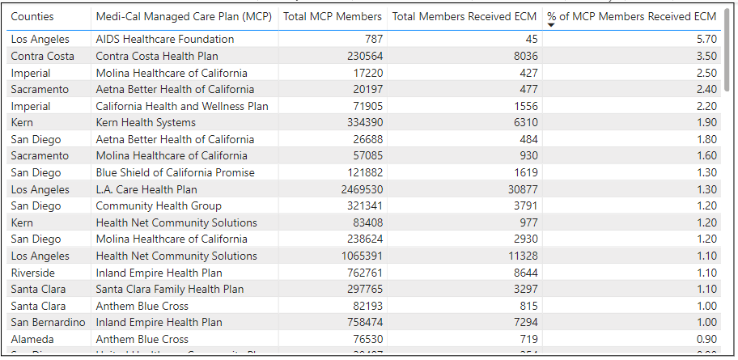
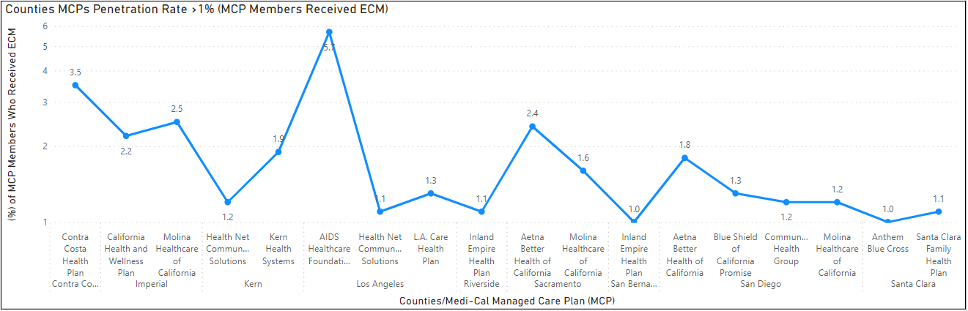

4) Penetration rates (in percentages) by counties and population of focus
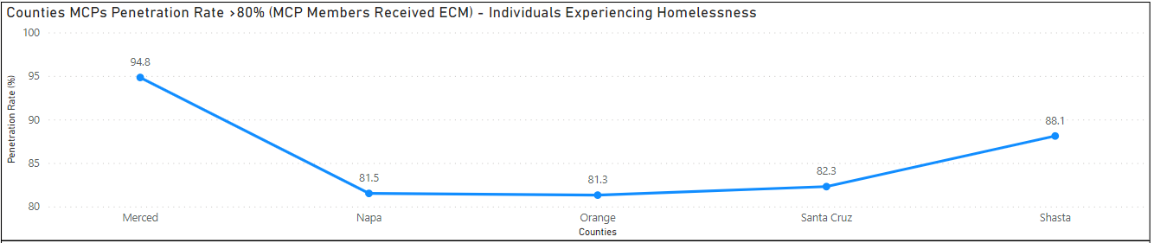
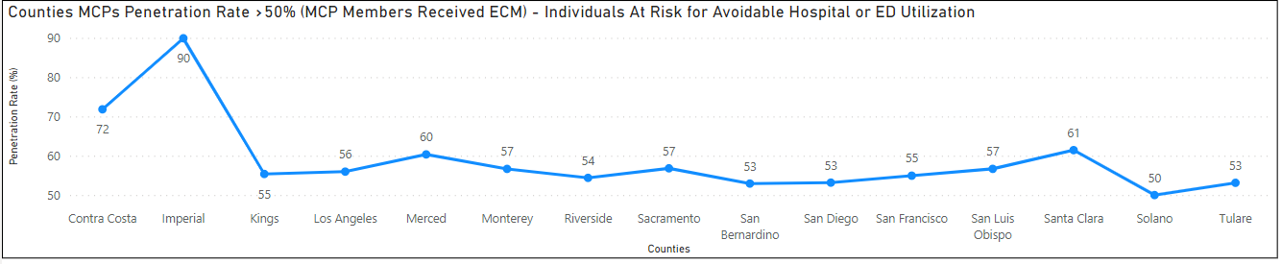
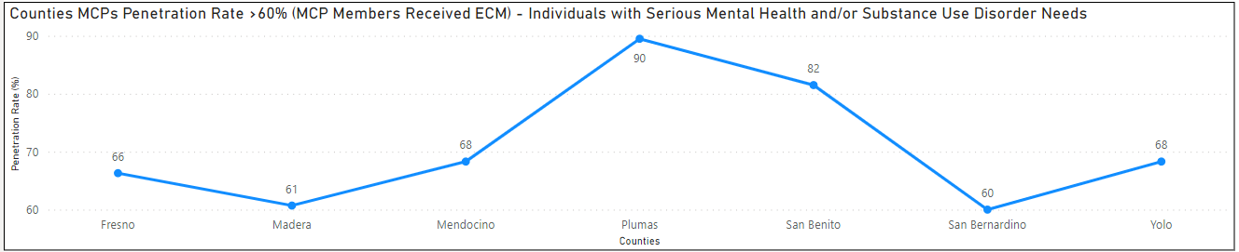
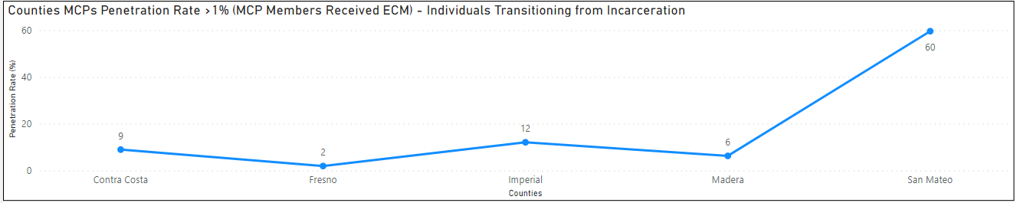

Community Supports (CS)

Source: Community Supports (CS) Implementation Data from CY 2022
Note:
- Community Supports are optional, and MCPs may elect which services to offer.
  - At the MCP level, this is a count of the total unique types of Community Supports services offered by each MCP in a given county in 2022.
  - At the county level, this is a count of total unique types of Community Supports services offered by one or more MCPs in the county.
- MCPs may elect to offer new Community Supports services every six months.
  - At the MCP level, this is a count of the total unique types of Community Supports services that an MCP began offering on a specific date in that county.
  - At the county level, this is a count of total unique types of Community Supports services that were first offered by one or more MCPs on a given date.
- A member who received Community Supports in multiple counties or from multiple MCPs due to a relocation or plan change in 2022 may be counted multiple times in this report.
- A member can be eligible for and receive multiple Community Supports services. Post-processing, the terms “provided”, “eligible”, or “authorized for CS” are used interchangeably.
- “N/A” indicates Community Supports not offered by a given MCP at any point in 2022. Where an MCP reported a nonzero value for a Community Support not offered by the MCP at any point in 2022, the value is masked and instead reported as "N/A."
- To comply with data privacy standards, data points with a value under 11 at the plan level are suppressed and reported as <11. Post-processing by DHS reported the “<11” values as “11.”
  - Data points at the county level that are under 11 or are greater than 10 but could be used to deduce a masked plan-level value are reported as *. Rates that could be used to deduce a masked value are reported as *.
- Additional resource, Community Supports Fact Sheet

Sacramento Data

1) Number of MCP members provided and received CS Services in CY 2022, including penetration rate (in percentages)

2) Penetration rates (in percentages) by Managed Care Plans (MCPs)
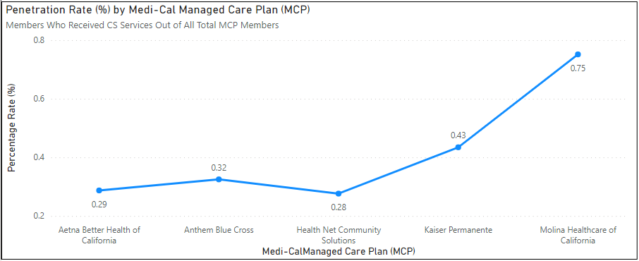
Counties | Managed Care Plan (MCP) | Total MCP Members | Total Members Received CS | Percentage (%)
Sacramento |  | 532,691 | 1,992 | .37%
Sacramento | Aetna Better Health of California | 20,197 | 58 | 0.29%
Sacramento | Anthem Blue Cross | 211,416 | 687 | 0.32%
Sacramento | Health Net Community Solutions | 129,908 | 359 | 0.28%
Sacramento | Kaiser Permanente | 113,477 | 493 | 0.43%
Sacramento | Molina Healthcare of California | 57,085 | 429 | 0.75%

Across all MCPs, less than 1% of all members (eligible or ineligible for CS) received CS services in CY 2022. Across 4 of the 5 MCPs, less than .5% of members received CS services in CY 2022.

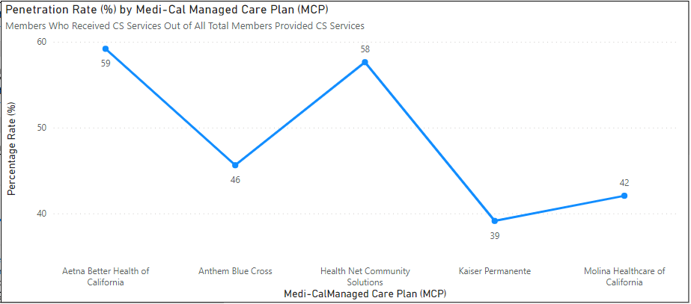
Counties | Managed Care Plan (MCP) | Total Members Provided/Eligible for CS | Total Members Received CS | Percentage (%)
Sacramento |  | 4,507 | 1,992 | 44%
Sacramento | Aetna Better Health of California | 98 | 58 | 59%
Sacramento | Anthem Blue Cross | 1,506 | 687 | 46%
Sacramento | Health Net Community Solutions | 623 | 359 | 58%
Sacramento | Kaiser Permanente | 1,260 | 493 | 39%
Sacramento | Molina Healthcare of California | 1,020 | 429 | 42%

Across all MCPs, close to 40% - 60% of all members who were determined to be eligible received the CS services for which they were authorized in CY 2022 received CS services.

3) Penetration rates (in percentages) of CS services members received by Managed Care Plans (MCPs)
Community Supports | Aetna Better Health of California |  | Anthem Blue Cross |  | Health Net Community Solutions |  | Kaiser Permanente |  | Molina Healthcare of California
 | n | % of members | n | % of members | n | % of members | n | % of members | n | % of members
Housing Transition and Navigation Services | 53 | .26% | 606 | .29% | 275 | .21% | 449 | .40% | 321 | .56%
Housing Deposits | 11 | .05% | 30 | .01% | 11 | .01% | NA | NA | 29 | .05%
Housing Tenancy and Sustaining Services | 0 | 0 | 108 | .05% | 30 | .02% | 79 | .07% | 39 | .07%
Short-Term Post-Hospitalization Housing | 11 | .05% | 40 | .02% | NA | NA | NA | NA | 11 | .02%
Recuperative Care | 11 | .05% | 37 | .02% | 18 |  | NA | NA | 24 | .04%
Respite Services | 0 | - | 0 | - | NA | NA | NA | NA | 11 | .02%
Day Habilitation Programs | 0 | - | 0 | - | NA | NA | NA | NA | 0 | -
Nursing Facility  Transition/Diversion to Assisted Living Facilities | 0 | - | NA | NA | NA | NA | NA | NA | NA | NA
Community Transition Services/ Nursing Facility Transition to Home | 0 | - | NA | NA | NA |  | NA | NA | NA | NA
Personal Care and Homemaker Services | 0 | - | 0 | - | NA | NA | NA | NA | 11
Environmental Accessibility Adaptations | 0 | - | 0 | - | 0 | - | NA | NA | NA | NA
Medically-Supportive Food/ Medically Tailored Meals | 11 | .05% | 72 | .03% | 38 | .03% | NA | NA | 76 | .13%
Sobering Centers | 11 | .05% | 11 | .01% | 32 | .02% | NA | NA | 20 | .04%
Asthma Remediation | 0 | - | 11 | .01% | 0 | .00% | NA | NA | 0 | -

4) CS services rates (in percentages) by Managed Care Plans (MCPs) and by housing services
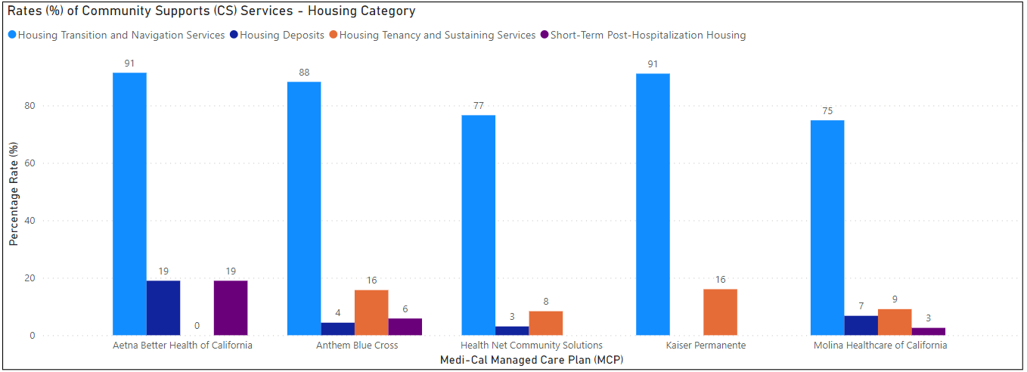
Numerator: Total number of services provided respective to the service
Denominator: Total members who received CS services

Managed Care Plan (MCP) | Total Members Who Received Community Supports | Housing Transition and Navigation Services | Housing Deposits | Housing Tenancy and Sustaining Services | Short-Term Post-Hospitalization Housing
Aetna Better Health of California | 58 | 53 | 11 | 0 | 11
Anthem Blue Cross | 687 | 606 | 30 | 108 | 40
Health Net Community Solutions | 359 | 275 | 11 | 30 | NA
Kaiser Permanente | 493 | 449 | NA | 79 | NA
Molina Healthcare of California | 429 | 321 | 29 | 39 | 11

Comparison Data Q1-Q3 2023 vs CY 2022

1) Rate of change (in percentages) by Managed Care Plans (MCPs) and by housing services
Community Supports | Aetna Better Health of California |  |  | Anthem Blue Cross |  |  | Health Net Community Solutions |  |  | Kaiser Permanente |  |  | Molina Healthcare of California
 | Q1 - Q3 2023 | CY 2022 | % Change | Q1 - Q3 2023 | CY 2022 | % Change | Q1 - Q3 2023 | CY 2022 | % Change | Q1 - Q3 2023 | CY 2022 | % Change |  | Q1 - Q3 2023 | CY 2022 | % Change
Housing Transition and Navigation Services | 381 | 53 | 618.9 | 3457 | 606 | 470.5 | 551 | 275 | 100.4 | 1448 | 449 | 222.5 |  | 711 | 321 | 121.5
Housing Deposits | 26 | 11 | 136.4 | 276 | 30 | 820.0 | 27 | 11 | 145.5 | 227 | N/A | N/A |  | 52 | 29 | 79.3
Housing Tenancy and Sustaining Services | 2 | 0 | 0 | 256 | 108 | 137.0 | 105 | 30 | 250.0 | 62 | 79 | -21.5 |  | 26 | 39 | -33.3
Short-Term Post-Hospitalization Housing | 4 | 11 | -63.6 | 5 | 40 | -87.5 | 3 | N/A | N/A | N/A | N/A | N/A |  | 10 | 11 | -9.1

Example of Percent (%) Change Calculation (to reference above)
Quantity | Value | Outcome
Q1-Q3 2023 number |  | 381
CY 2022 number |  | 53
Difference | 381-53 | 328
Ratio of difference to CY 2022 | 328/53 | 6.19
Ratio multiplied by 100 | 6.19*100 | 618.9

2) Penetration Rate and Percentage Point Difference by Managed Care Plans (MCPs) and by housing services
Community Supports | Aetna Better Health of California |  |  | Anthem Blue Cross |  |  | Health Net Community Solutions |  |  | Kaiser Permanente |  |  | Molina Healthcare of California
 | Q1 - Q3 2023 | CY 2022 | Point Change | Q1 - Q3 2023 | CY 2022 | Point Change | Q1 - Q3 2023 | CY 2022 | Point Change | Q1 - Q3 2023 | CY 2022 | Point Change | Q1 - Q3 2023 | CY 2022 | Point Change
Housing Transition and Navigation Services | 1.89% | 0.26% | 1.62 | 1.64% | 0.29% | 1.35 | 0.42% | 0.21% | 0.21 | 1.28% | 0.40% | 0.88 | 1.25% | 0.56% | 0.68
Housing Deposits | 0.13% | 0.05% | 0.07 | 0.13% | 0.01% | 0.12 | 0.02% | 0.01% | 0.01 | 0.20% | N/A | N/A | 0.09% | 0.05% | 0.04
Housing Tenancy and Sustaining Services | 0.01% | 0.00% | 0.01 | 0.12% | 0.05% | 0.07 | 0.08% | 0.02% | 0.06 | 0.05% | 0.07% | -0.01 | 0.05% | 0.07% | -0.02
Short-Term Post-Hospitalization Housing | 0.02% | 0.05% | -0.03 | 0.00% | 0.02% | -0.02 | 0.00% | N/A | N/A | N/A | N/A | N/A | 0.02% | 0.02% | 0.00
Total MCP Members in CY 2022 | 20,197 |  |  | 211,416 |  |  | 129,908 |  |  | 113,477 |  |  | 57,085

3) Baseline data for Public Health CHIP SMART Goal
- Sacramento County estimated population in 2022 (July 1, 2022): 1,584,169
  - Source: https://www.census.gov/quickfacts/fact/table/sacramentocountycalifornia#
- Sacramento County estimated persons under 18 years old, percent: 22.7%
  - Source: https://www.census.gov/quickfacts/fact/table/sacramentocountycalifornia#
- Sacramento County estimated persons per household, 2027-2021: 2.77%
  - Source: https://www.census.gov/quickfacts/fact/table/sacramentocountycalifornia#
- Total MCP members in an average month of CY 2022: 532,691
  - Source: https://www.dhcs.ca.gov/Documents/MCQMD/Community-Supports-Implementation-Data-CY-2022-County-Plan-Data.pdf
- Total MCP members by zip code, Sept 2023: 17,847
  - Source: https://data.chhs.ca.gov/dataset/medi-cal-certified-eligible-counts-by-month-of-eligibility-zip-code-and-sex/resource/55391885-76d4-4fa1-9af8-74844386fc48
- Population size in zip code 95820: 36,437
  - Source: https://map.healthyplacesindex.org/?redirect=false
- Population size in census tract 44.01: 3,788
  - Source: https://map.healthyplacesindex.org/?redirect=false

 | Population | Total MCP Members | Percentage (%) of population are MCP Members | Estimate of MCP Members | If goal is 5%, Number of MCP Members | If goal is 10%, Number of MCP Members | If goal is 50%, Number of MCP Members | If goal is 80%, Number of MCP Members
Sacramento County | 1,584,169 | 532,691 | 33.63% | 538617.46 | 26930.87 | 53861.75 | 269308.73 | 430893.97
Census Tract: 44.01 | 3,788 | n/a | Used County level percentage of 34% as the baseline | 1287.92 | 64.40 | 128.79 | 643.96 | 1030.34
Zip Code: 95820 | 36,437 | 17,847 | 48.98% | 17854.13 | 892.71 | 1785.41 | 8927.065 | 14283.30

 | Population | Estimate Population of persons under the age of 18 years old | Estimate Percentage (%) of population under the age of 18 years old | Estimate Number of Families (if each family has 3 persons under the age of 18 years old) | Total MCP Members | Percentage (%) of population are MCP members | Estimate Number of MCP Families | If goal is 5%, Number of MCP Families | If goal is 10%, Number of MCP Families | If goal is 50%, Number of MCP Families | If goal is 80%, Number of MCP Families
Sacramento County | 1,584,169 | 364358.87 | 22.7% | 121452.96 | 532,691 | 33.63% | 41294.01 | 2064.70 | 4129.40 | 20647.00 | 33035.20
Census Tract: 44.01 | 3,788 | 871.24 | Used County level percentage of 23% as the baseline | 290.41 | n/a | Used County level percentage of 34% as the baseline | 98.74 | 4.94 | 9.87 | 49.37 | 78.99
Zip Code: 95820 | 36,437 | 8380.51 | Used County level percentage of 23% as the baseline | 2793.50 | 17,847 | 48.98% | 1368.82 | 68.44 | 136.88 | 684.41 | 1095.05

Comparison Data to Similar Counties

1) Number of MCP members provided and received CS Services in CY 2022, including penetration rate (in percentages) near/close in member size as to Sacramento
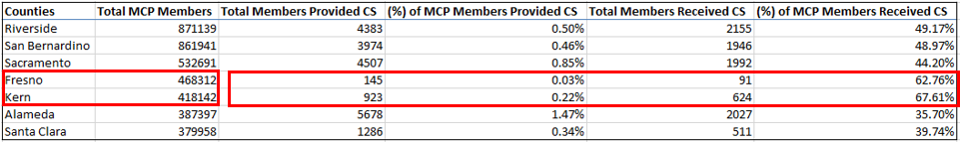
Less than 1% of Fresno and Kern MCP members were provided/eligible for CS services; over 62% received CS services.

2) Comparable counties with MCP members who received CS services near/close in number to Sacramento members
Counties | Total MCP Members | Number of CS Services Provided | Number of CS Services Received
Orange | 896,576 | 8,540 | 4904
Riverside | 871,139 | 4,383 | 2155
Alameda | 387,397 | 5,678 | 2027
Sacramento | 532,691 | 4,507 | 1992
San Bernardino | 861,941 | 3,974 | 1946
San Diego | 891,851 | 2,601 | 1518
Kern | 418,142 | 923 | 624
Note: Riverside, Alameda, and San Bernardino do not over similar MCPs options. The county that offers similar MCP plans comparable to Sacramento is San Diego.

3) CS services by comparable counties as Sacramento and by housing services (Note: Housing services is categorized by DHS not by DHCS)
Community Supports | Riverside | Alameda | Sacramento | San Bernardino | San Diego
Housing Transition and Navigation Services | 1275 | 511 | 1678 | 1174 | 834
Housing Deposits | * | 254 | * | 65 | *
Housing Tenancy and Sustaining Services | * | 1323 | 255 | * | *
Short-Term Post-Hospitalization Housing | 18 | 0 | * | 19 | *

Note: Riverside, Alameda, and San Bernardino does not offer the similar MCPs as Sacramento.

4) CS services by Managed Care Plans (MCPs) in Sacramento and San Diego counties by housing services
Community Supports | Aetna Better Health of California |  | Anthem Blue Cross |  | Blue Shield of California Promise |  | Health Net Community Solutions |  | Kaiser Permanente |  | Molina Healthcare of California
 | Sac | SD | Sac | SD | Sac | SD | Sac | SD | Sac | SD | Sac | SD
Housing Transition and Navigation Services | 53 | 29 | 606 | - | - | 259 | 275 | 25 | 449 | 15 | 321 | 374
Housing Deposits | 11 | 0 | 30 | - | - | 11 | 11 | 0 | N/A | NA | 29 | 13
Housing Tenancy and Sustaining Services | 0 | 0 | 108 | - | - | 33 | 30 | 11 | 79 | 11 | 39 | 27
Short-Term Post-Hospitalization Housing | 11 | 0 | 40 | - | - | 11 | N/A | N/A | N/A | NA | 11 | NA

Note: San Diego also offers Community Health Group and UniteHealthcare Community Plan. These plans are omitted from the table since Sacramento does not offer these plans.

5) CS services rates (in percentages) by Managed Care Plans (MCPs) in Sacramento and San Diego counties by housing services
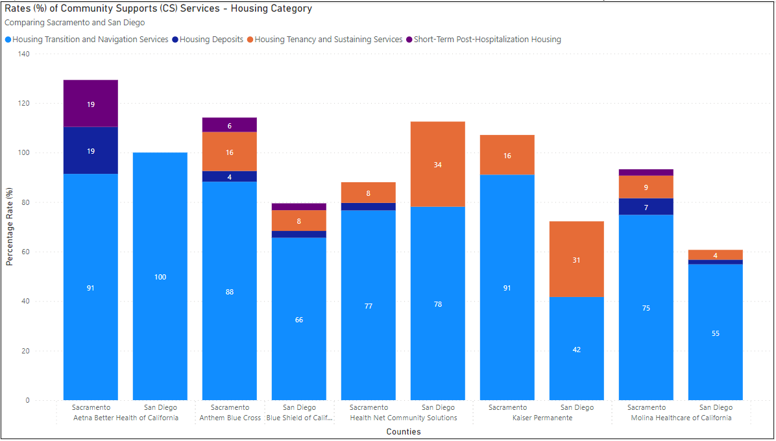
Note: San Diego also offers Community Health Group and UniteHealthcare Community Plan. These plans are omitted from the visual since Sacramento does not offer these plans.
Community Supports | Aetna Better Health of California |  | Anthem Blue Cross |  | Blue Shield of California Promise |  | Health Net Community Solutions |  | Kaiser Permanente |  | Molina Healthcare of California
 | Sac | SD | Sac | SD | Sac | SD | Sac | SD | Sac | SD | Sac | SD
Housing Transition and Navigation Services | 53 | 29 | 606 | - | - | 259 | 275 | 25 | 449 | 15 | 321 | 374
Housing Deposits | 11 | 0 | 30 | - | - | 11 | 11 | 0 | N/A | NA | 29 | 13
Housing Tenancy and Sustaining Services | 0 | 0 | 108 | - | - | 33 | 30 | 11 | 79 | 11 | 39 | 27
Short-Term Post-Hospitalization Housing | 11 | 0 | 40 | - | - | 11 | N/A | N/A | N/A | NA | 11 | NA
Total Members Who Received Community Supports | 58 | 29 | 687 | - | - | 395 | 359 | 32 | 493 | 36 | 429 | 682

